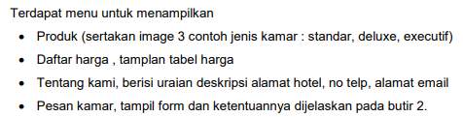

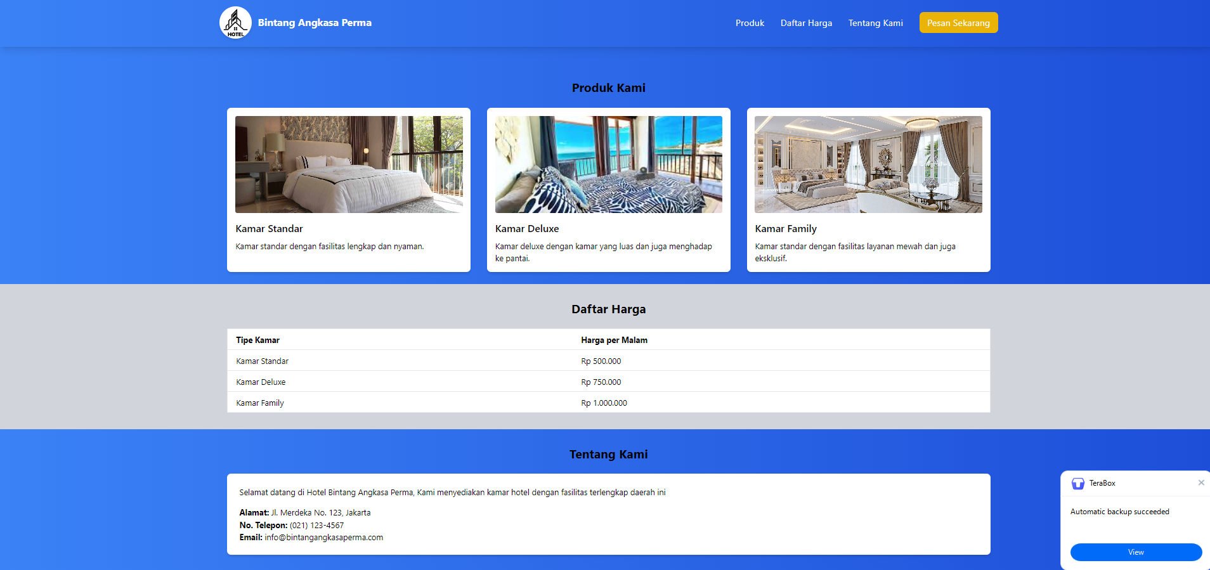

Source Code halaman depan

<!DOCTYPE *html*>

<html *lang*="en">

<head>

    <meta *charset*="UTF-8">

    <meta *name*="viewport" *content*="width=device-width, initial-scale=1.0">

    <title>Landing Page</title>

    <link *rel*="shortcut icon" *href*="https://img.freepik.com/premium-vector/hotel-icon-logo-vector-design-template_827767-3569.jpg" *type*="image/x-icon">

    <script *src*="https://cdn.tailwindcss.com"></script>

</head>

<body *class*="bg-gradient-to-r from-blue-500 to-blue-700">

    <nav *class*="bg-gradient-to-r from-blue-500 to-blue-700 py-4 shadow-lg">

        <div *class*="container mx-auto flex items-center justify-between">

            <div *class*="flex items-center">

                <img *src*="https://img.freepik.com/premium-vector/hotel-icon-logo-vector-design-template_827767-3569.jpg" *class*="w-16 h-16 mr-3 rounded-full shadow-md" *alt*="Hotel Logo">

                <a *href*="index.html">

                    <span *class*="text-white text-xl font-bold">Bintang Angkasa Perma</span>

                </a>

            </div>

            <ul *class*="flex space-x-8 text-lg">

                <li><a *href*="#produk" *class*="text-white hover:text-gray-200 transition duration-300">Produk</a></li>

                <li><a *href*="#harga" *class*="text-white hover:text-gray-200 transition duration-300">Daftar Harga</a></li>

                <li><a *href*="#tentang" *class*="text-white hover:text-gray-200 transition duration-300">Tentang Kami</a></li>

                <li><a *href*="pesan.php" *class*="bg-yellow-500 text-white hover:bg-yellow-600 py-2 px-4 rounded-lg transition duration-300">Pesan Sekarang</a></li>

            </ul>

        </div>

    </nav>

    <section *id*="produk" *class*="py-6 mt-10">

        <div *class*="container mx-auto px-4">

            <h2 *class*="text-2xl font-bold mb-6 text-center">Produk Kami</h2>

            <div *class*="grid grid-cols-1 md:grid-cols-3 gap-8">

                <div *class*="bg-white p-4 rounded-lg shadow-md ">

                    <img *src*="https://www.pantaimentari.com/upload/2021/09/Pencahayaan_kamar-2.jpg" *alt*="Kamar Standar" *class*="w-full h-48 object-cover rounded">

                    <h3 *class*="text-xl font-semibold mt-4">Kamar Standar</h3>

                    <p *class*="mt-2">Kamar standar dengan fasilitas lengkap dan nyaman.</p>

                </div>

                <div *class*="bg-white p-4 rounded-lg shadow-md">

                    <img *src*="https://encrypted-tbn0.gstatic.com/images?q=tbn:ANd9GcSG-cBjE2ce-NQGLtdJ2gDA6QJtHu82PGplVw&s" *alt*="Kamar Standar" *class*="w-full h-48 object-cover rounded">

                    <h3 *class*="text-xl font-semibold mt-4">Kamar Deluxe</h3>

                    <p *class*="mt-2">Kamar deluxe dengan kamar yang luas dan juga menghadap ke pantai.</p>

                </div>

                <div *class*="bg-white p-4 rounded-lg shadow-md">

                    <img *src*="https://i2.wp.com/www.emporiointerior.com/upload/blog/model-interior-rumah-sultan-super-mewah-di-jambi-review-desain-interior-kamar-tidur-utama-klasik-part-16-180323014657366237.jpg" *alt*="Kamar Standar" *class*="w-full h-48 object-cover rounded">

                    <h3 *class*="text-xl font-semibold mt-4">Kamar Family</h3>

                    <p *class*="mt-2">Kamar standar dengan fasilitas layanan mewah dan juga eksklusif.</p>

                </div>

            </div>

        </div>

    </section>

    <section *id*="harga" *class*=" py-8 bg-gray-300">

        <div *class*="container mx-auto px-4">

            <h2 *class*="text-2xl font-bold mb-6 text-center">Daftar Harga</h2>

            <div *class*="overflow-x-auto">

                <table *class*="min-w-full bg-white border border-gray-200">

                    <thead>

                        <tr>

                            <th *class*="py-2 px-4 border-b text-left">Tipe Kamar</th>

                            <th *class*="py-2 px-4 border-b text-left">Harga per Malam</th>

                        </tr>

                    </thead>

                    <tbody>

                        <tr>

                            <td *class*="py-2 px-4 border-b">Kamar Standar</td>

                            <td *class*="py-2 px-4 border-b">Rp 500.000</td>

                        </tr>

                        <tr>

                            <td *class*="py-2 px-4 border-b">Kamar Deluxe</td>

                            <td *class*="py-2 px-4 border-b">Rp 750.000</td>

                        </tr>

                        <tr>

                            <td *class*="py-2 px-4 border-b">Kamar Family</td>

                            <td *class*="py-2 px-4 border-b">Rp 1.000.000</td>

                        </tr>

                    </tbody>

                </table>

            </div>

        </div>

    </section>

    <section *id*="tentang" *class*="py-8">

        <div *class*="container mx-auto px-4">

            <h2 *class*="text-2xl font-bold mb-6 text-center">Tentang Kami</h2>

            <div *class*="bg-white p-6 rounded-lg shadow-md">

                <p>Selamat datang di Hotel Bintang Angkasa Perma, Kami menyediakan kamar hotel dengan fasilitas terlengkap daerah ini</p>

                <ul *class*="mt-4">

                    <li><strong>Alamat:</strong> Jl. Merdeka No. 123, Jakarta</li>

                    <li><strong>No. Telepon:</strong> (021) 123-4567</li>

                    <li> <a *href*="mailto:info@bintangangkasaperma.com"> <strong>Email:</strong> info@bintangangkasaperma.com </a></li>

                </ul>

            </div>

        </div>

    </section>

</body>

</html>

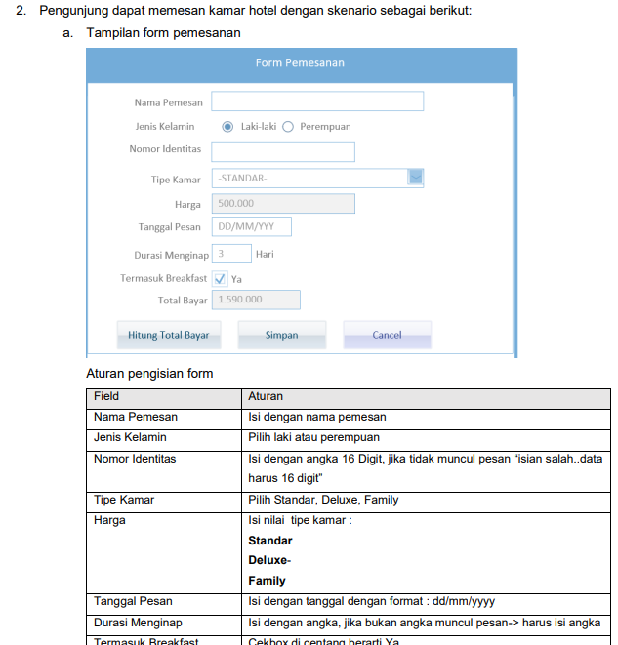

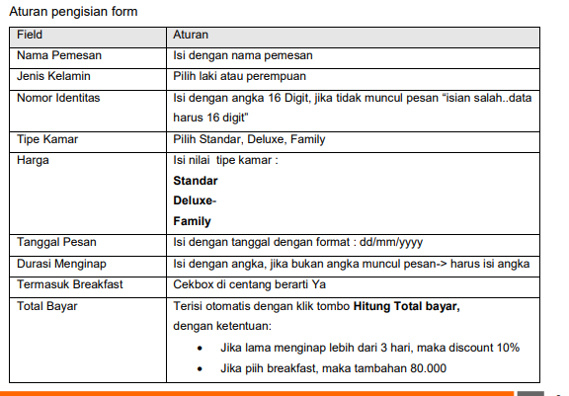

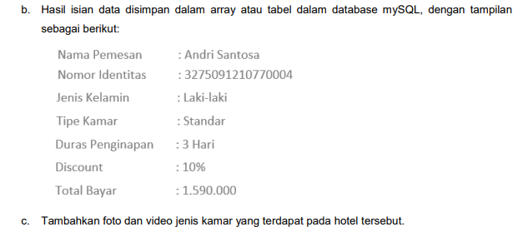

Tampilan Halaman Form

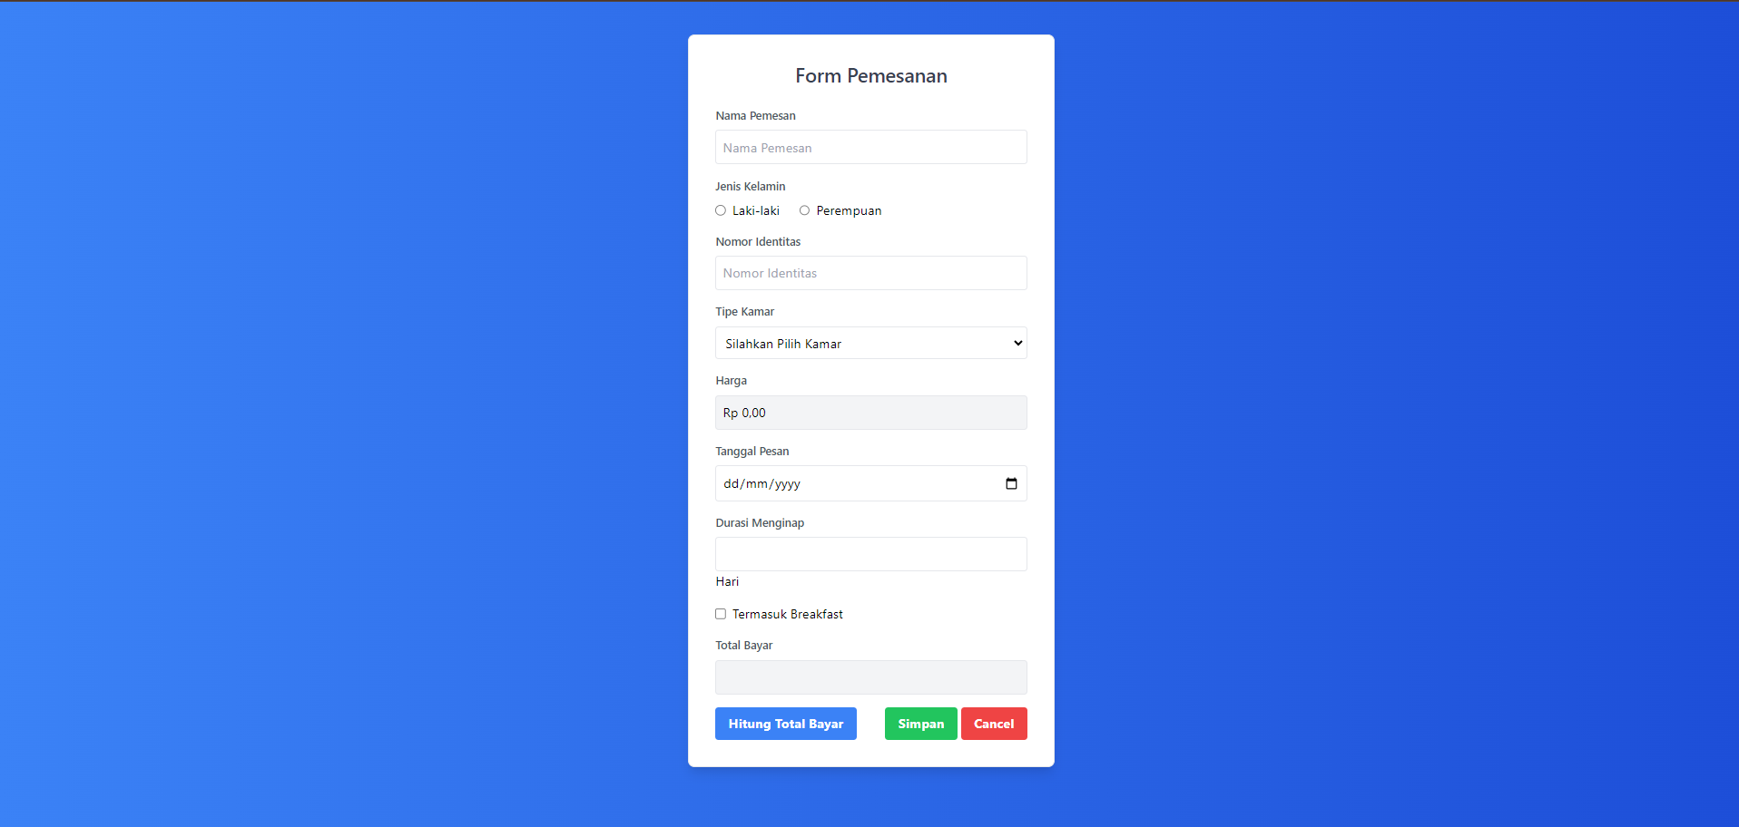

<!DOCTYPE *html*>

<html *lang*="en">

<head>

    <meta *charset*="UTF-8">

    <meta *name*="viewport" *content*="width=device-width, initial-scale=1.0">

    <title>Pemesanan Hotel</title>

    <script *src*="https://cdn.tailwindcss.com"></script>

</head>

<body *class*="bg-gradient-to-r from-blue-500 to-blue-700">

    <div *class*="max-w-md mx-auto bg-white p-8 border border-gray-200 mt-10 rounded-lg shadow-lg">

        <h2 *class*="text-2xl font-semibold text-center text-gray-700">Form Pemesanan</h2>

        <form *action*="hasil.php" *method*="post" *class*="mt-6">

            <div *class*="mb-4">

                <label *class*="block text-gray-600 text-sm font-semibold mb-2">Nama Pemesan</label>

                <input *type*="text" *placeholder*="Nama Pemesan" *class*="block w-full p-2 border rounded border-gray-200" *name*="nama_pemesan" *required*>

            </div>

            <div *class*="mb-4">

                <label *class*="block text-gray-600 text-sm font-semibold mb-2">Jenis Kelamin</label>

                <div *class*="flex items-center">

                    <input *type*="radio" *name*="gender" *id*="laki" *value*="Laki-Laki" *class*="mr-2" *required*> Laki-laki

                    <input *type*="radio" *name*="gender" *id*="perempuan" *value*="Perempuan" *class*="ml-6 mr-2" *required*> Perempuan

                </div>

            </div>

            <div *class*="mb-4">

                <label *class*="block text-gray-600 text-sm font-semibold mb-2">Nomor Identitas</label>

                <input *type*="number" *id*="No Identitas" *placeholder*="Nomor Identitas" *name*="no_identitas" *class*="block w-full p-2 border rounded border-gray-200">

                <div *id*="error_message"></div>

            </div>

            <div *class*="mb-4">

                <label *class*="block text-gray-600 text-sm font-semibold mb-2">Tipe Kamar</label>

                <select *class*="block w-full p-2 border rounded border-gray-200" *name*="tipe_kamar" *required* *id*="tipe_kamar">

                    <option *disabled* *selected*>Silahkan Pilih Kamar</option>

                    <option *value*="Standar">STANDAR</option>

                    <option *value*="Deluxe">DELUXE</option>

                    <option *value*="Family">FAMILY</option>

                </select>

            </div>

            <div *class*="mb-4">

                <label *class*="block text-gray-600 text-sm font-semibold mb-2">Harga</label>

                <input *type*="text" *id*="harga"  *disabled* *class*="block w-full p-2 border rounded border-gray-200 bg-gray-100">

                <input *type*="hidden" *id*="harga_hidden" *name*="harga_kamar" *class*="block w-full p-2 border rounded border-gray-200 bg-gray-100">

            </div>

            <div *class*="mb-4">

                <label *class*="block text-gray-600 text-sm font-semibold mb-2">Tanggal Pesan</label>

                <input *type*="date" *min*="<?php echo date("Y-m-d") ?>" *name*="tanggal_pesan" *placeholder*="DD/MM/YYYY" *class*="block w-full p-2 border rounded border-gray-200">

            </div>

            <div *class*="mb-4">

                <label *class*="block text-gray-600 text-sm font-semibold mb-2">Durasi Menginap</label>

                <input *type*="text" *id*="nginap" *name*="durasi_nginap" *class*="block w-full p-2 border rounded border-gray-200">

                <label >Hari</label>

                <div *id*="nginap_error"></div>

            </div>

            <div *class*="flex items-center mb-4">

                <input *type*="checkbox" *id*="breakfast" *name*="breakfast" *class*="mr-2"> Termasuk Breakfast

            </div>

            <div *class*="mb-4">

                <label *class*="block text-gray-600 text-sm font-semibold mb-2">Total Bayar</label>

                <input *type*="text" *id*="total_harga" *disabled* *class*="block w-full p-2 border rounded border-gray-200 bg-gray-100">

                <input *type*="hidden" *name*="total_harga" *id*="total_harga_hidden"  *class*="block w-full p-2 border rounded border-gray-200 bg-gray-100">

                <input *type*="hidden" *name*="diskon" *id*="diskon">

            </div>

            <div *class*="flex justify-between items-center">

                <button *type*="button" *id*="tombol_hitung" *class*="bg-blue-500 hover:bg-blue-700 text-white font-bold py-2 px-4 rounded">

                    Hitung Total Bayar

                </button>

                <div>

                    <button *type*="submit" *id*="submit_button" *class*="bg-green-500 hover:bg-green-700 text-white font-bold py-2 px-4 rounded" *disabled*>

                        Simpan

                    </button>

                    <button *type*="reset" *class*="bg-red-500 hover:bg-red-700 text-white font-bold py-2 px-4 rounded">

                        Cancel

                    </button>

                </div>

            </div>

        </form>

    </div>

    <script>

        var no_identitas = document.getElementById('No Identitas');

        var errorContainer = document.getElementById('error_message'); *// Tempat untuk menampilkan pesan error*

        var submitButton = document.getElementById('submit_button'); *// Tombol submit*

        var hasErrorNoIdentitas = false;

        var hasErrorNginap = false;

        no_identitas.addEventListener('change', (e)=>{

            var inputLength = e.target.value.length

            console.log(inputLength);

*if*(inputLength != 16){

                errorContainer.innerHTML = "<div class='text-red-500'>Isian salah.. data harus 16 digit.</div>"

                hasErrorNoIdentitas = true

            }*else*{

                errorContainer.innerHTML = ""

                hasErrorNoIdentitas = false

            }

            checkFormValidity()

        })

        function checkFormValidity() {

*if* (hasErrorNoIdentitas || hasErrorNginap ) {

                submitButton.disabled = true; *// Disable tombol submit jika ada error*

            } *else* {

                submitButton.disabled = false; *// Enable tombol submit jika tidak ada error*

            }

        }

        var nginap = document.getElementById('nginap');

        var error_nginap = document.getElementById('nginap_error')

        nginap.addEventListener('change', (e)=>{

            var input = parseInt(e.target.value, 10)

*if*(isNaN(input) || input <= 0){

                error_nginap.innerHTML = "<div class='text-red-500'>Harus berupa angka</div>"

                hasErrorNginap = true

            }*else*{

                error_nginap.innerHTML = ""

                hasErrorNginap = false

            }

            checkFormValidity()

        })

        var tipeKamar = document.getElementById('tipe_kamar');

        var hargaInput = document.getElementById('harga');

        var hargaHiddenInput = document.getElementById('harga_hidden');

        tipeKamar.addEventListener('change', () =>{

            var harga

*switch*(tipeKamar.value){

*case* "Standar" :

                    harga = 500000

*break*;

*case* "Deluxe" :

                    harga = 750000

*break*

*case* "Family" :

                    harga = 1000000

*break*

*default* :

                    harga = 0

            }

            var formattedHarga = harga.toLocaleString('id-ID', {style: 'currency', currency: "IDR"})

            hargaInput.value = formattedHarga

            hargaHiddenInput.value = harga

            console.log(hargaHiddenInput.value)

        })

        tipeKamar.dispatchEvent(new Event('change'));

        var tombolHitung =document.getElementById('tombol_hitung')

        tombolHitung.addEventListener('click', (e)=>{

            var hargaKamar = {

                "Standar" : 500000,

                "Deluxe" : 750000,

                "Family" : 1000000

            }

            var tipe_kamar_value = tipeKamar.value;

            var durasi_nginap_value = parseInt(nginap.value)

            var breakfast = document.getElementById("breakfast").checked

            var hargaPerMalam =hargaKamar[tipe_kamar_value]

            var totalHarga = hargaPerMalam * durasi_nginap_value

            var is_diskon = document.getElementById('diskon').value

*if*(durasi_nginap_value > 3){

                totalHarga = totalHarga * 0.9

            }

*if* (breakfast){

                totalHarga += 80000

            }

            var formattedTotalHarga = totalHarga.toLocaleString('id-ID', {style: 'currency', currency: "IDR"})

            document.getElementById('total_harga').value = formattedTotalHarga

            document.getElementById('total_harga_hidden').value = formattedTotalHarga

            console.log(document.getElementById('total_harga_hidden').value)

        })

    </script>

</body>

</html>

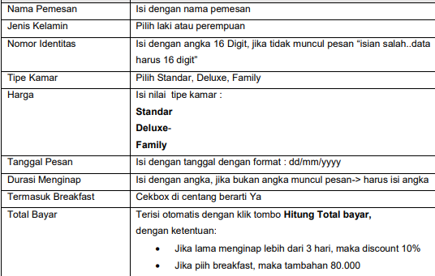

Validasi tiap formnya

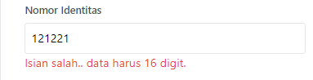

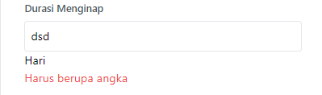

Dengan menggunakan javascript dibawah ini

    <script>

        var no_identitas = document.getElementById('No Identitas');

        var errorContainer = document.getElementById('error_message'); *// Tempat untuk menampilkan pesan error*

        var submitButton = document.getElementById('submit_button'); *// Tombol submit*

        var hasErrorNoIdentitas = false;

        var hasErrorNginap = false;

        no_identitas.addEventListener('change', (e)=>{

            var inputLength = e.target.value.length

            console.log(inputLength);

*if*(inputLength != 16){

                errorContainer.innerHTML = "<div class='text-red-500'>Isian salah.. data harus 16 digit.</div>"

                hasErrorNoIdentitas = true

            }*else*{

                errorContainer.innerHTML = ""

                hasErrorNoIdentitas = false

            }

            checkFormValidity()

        })

        function checkFormValidity() {

*if* (hasErrorNoIdentitas || hasErrorNginap ) {

                submitButton.disabled = true; *// Disable tombol submit jika ada error*

            } *else* {

                submitButton.disabled = false; *// Enable tombol submit jika tidak ada error*

            }

        }

        var nginap = document.getElementById('nginap');

        var error_nginap = document.getElementById('nginap_error')

        nginap.addEventListener('change', (e)=>{

            var input = parseInt(e.target.value, 10)

*if*(isNaN(input) || input <= 0){

                error_nginap.innerHTML = "<div class='text-red-500'>Harus berupa angka</div>"

                hasErrorNginap = true

            }*else*{

                error_nginap.innerHTML = ""

                hasErrorNginap = false

            }

            checkFormValidity()

        })

        var tipeKamar = document.getElementById('tipe_kamar');

        var hargaInput = document.getElementById('harga');

        var hargaHiddenInput = document.getElementById('harga_hidden');

        tipeKamar.addEventListener('change', () =>{

            var harga

*switch*(tipeKamar.value){

*case* "Standar" :

                    harga = 500000

*break*;

*case* "Deluxe" :

                    harga = 750000

*break*

*case* "Family" :

                    harga = 1000000

*break*

*default* :

                    harga = 0

            }

            var formattedHarga = harga.toLocaleString('id-ID', {style: 'currency', currency: "IDR"})

            hargaInput.value = formattedHarga

            hargaHiddenInput.value = harga

            console.log(hargaHiddenInput.value)

        })

        tipeKamar.dispatchEvent(new Event('change'));

        var tombolHitung =document.getElementById('tombol_hitung')

        tombolHitung.addEventListener('click', (e)=>{

            var hargaKamar = {

                "Standar" : 500000,

                "Deluxe" : 750000,

                "Family" : 1000000

            }

            var tipe_kamar_value = tipeKamar.value;

            var durasi_nginap_value = parseInt(nginap.value)

            var breakfast = document.getElementById("breakfast").checked

            var hargaPerMalam =hargaKamar[tipe_kamar_value]

            var totalHarga = hargaPerMalam * durasi_nginap_value

            var is_diskon = document.getElementById('diskon').value

*if*(durasi_nginap_value > 3){

                totalHarga = totalHarga * 0.9

            }

*if* (breakfast){

                totalHarga += 80000

            }

            var formattedTotalHarga = totalHarga.toLocaleString('id-ID', {style: 'currency', currency: "IDR"})

            document.getElementById('total_harga').value = formattedTotalHarga

            document.getElementById('total_harga_hidden').value = formattedTotalHarga

            console.log(document.getElementById('total_harga_hidden').value)

        })

    </script>

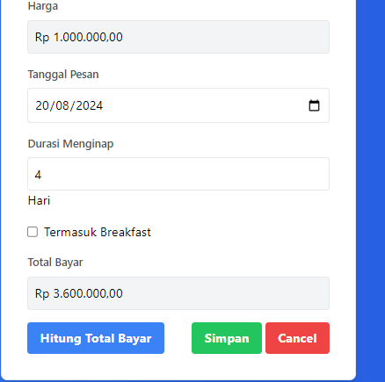

Diskon 10 % untuk pengguna yang menginap lebih dari 3 hari

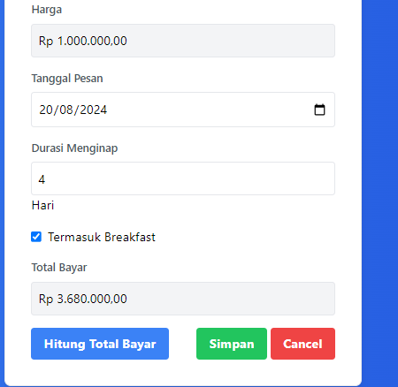

Breakfast dengan tambah 80.000 jika di centang



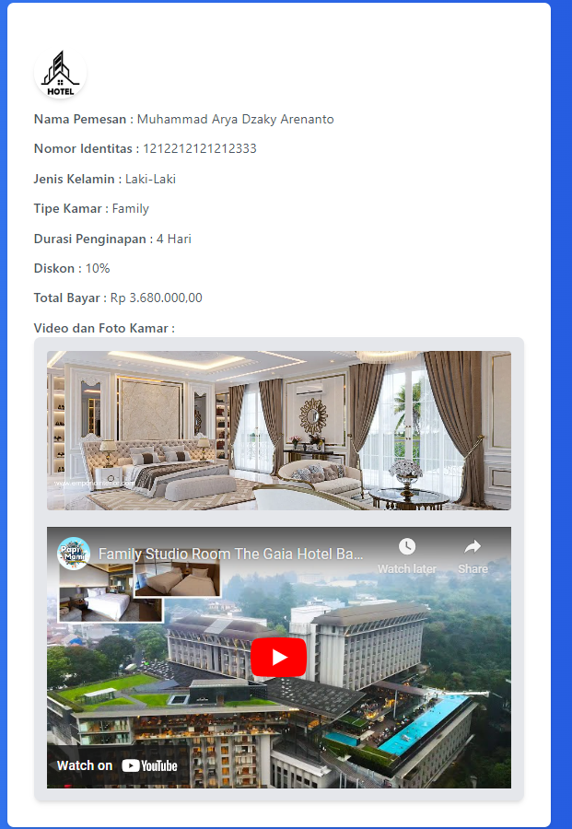

Tipe Family

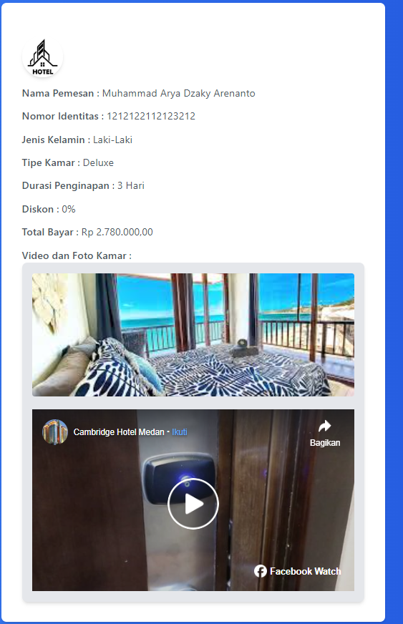

Tipe deluxe

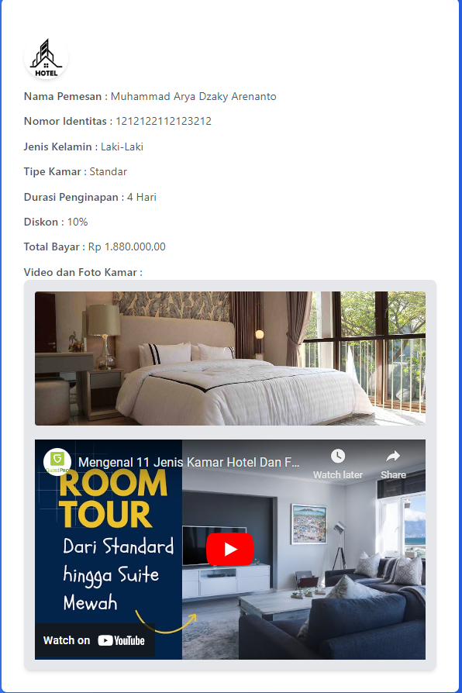

Tipe Standard

Berikut source code untuk tampilan hasil dari form input

<?php

*if*($_SERVER['REQUEST_METHOD'] == 'POST'){

       $nama_pemesan =  $_POST['nama_pemesan'];

       $jenis_kelamin = $_POST["gender"];

       $no_identitas = $_POST["no_identitas"];

       $tipe_kamar = $_POST["tipe_kamar"];

       $harga_kamar = $_POST["harga_kamar"];

       $tanggal_pesan = $_POST["tanggal_pesan"];

       $durasi_nginap = $_POST["durasi_nginap"];

       $breakfast = isset($_POST["breakfast"]) ?  "Ya" : "Tidak";

       $total_harga = $_POST["total_harga"];

       $diskon = $_POST["diskon"];

    }*else*{

        echo "Illegal Request";

*die*;

    }

?>

<!DOCTYPE *html*>

<html *lang*="en">

<head>

    <meta *charset*="UTF-8">

    <meta *name*="viewport" *content*="width=device-width, initial-scale=1.0">

    <title>Hasil Pemesanan</title>

    <script *src*="https://cdn.tailwindcss.com"></script>

    <script *async* *defer* *crossorigin*="anonymous" *src*="https://connect.facebook.net/id_ID/sdk.js#xfbml=1&version=v20.0" *nonce*="jjUSuSov"></script>

</head>

<body *class*="bg-gradient-to-r from-blue-500 to-blue-700">

<div *class*="flex items-center justify-center h-screen">

    <div *class*="bg-white p-8 rounded-lg shadow-md text-gray-600">

        <img *src*="https://img.freepik.com/premium-vector/hotel-icon-logo-vector-design-template_827767-3569.jpg" *class*="w-16 h-16 mr-3 rounded-full shadow-md  items-center mt-5" *alt*="">

        <div *class*="mt-3">

            <span *class*="font-semibold">Nama Pemesan</span> : <?= htmlspecialchars($nama_pemesan) ?>

        </div>

        <div *class*="mt-3">

            <span *class*="font-semibold">Nomor Identitas</span> : <?= htmlspecialchars($no_identitas) ?>

        </div>

        <div *class*="mt-3">

            <span *class*="font-semibold">Jenis Kelamin</span> : <?= htmlspecialchars($jenis_kelamin) ?>

        </div>

        <div *class*="mt-3">

            <span *class*="font-semibold">Tipe Kamar</span> : <?= htmlspecialchars($tipe_kamar) ?>

        </div>

        <div *class*="mt-3">

            <span *class*="font-semibold">Durasi Penginapan</span> : <?= htmlspecialchars($durasi_nginap) ?> Hari

        </div>

        <div *class*="mt-3">

            <span *class*="font-semibold">Diskon</span> :

            <?= $durasi_nginap > 3 ? '10%' : '0%' ?>

        </div>

        <div *class*="mt-3">

            <span *class*="font-semibold">Total Bayar</span> : <?= htmlspecialchars($total_harga) ?>

        </div>

        <div *class*="mt-3">

            <span *class*="font-semibold">Video dan Foto Kamar</span> : <?php *if*($tipe_kamar == "Standar" ){?>

                <div *class*="bg-gray-200 p-4 rounded-lg shadow-md ">

                    <img *src*="https://www.pantaimentari.com/upload/2021/09/Pencahayaan_kamar-2.jpg" *alt*="Kamar Standar" *class*="w-full h-48 object-cover rounded">

                    <iframe *width*="560" *class*="mt-5" *height*="315" *src*="https://www.youtube.com/embed/5jsAsamJeWE?si=1kjlyuPRN82c0gqN" *title*="YouTube video player" *frameborder*="0" *allow*="accelerometer; autoplay; clipboard-write; encrypted-media; gyroscope; picture-in-picture; web-share" *referrerpolicy*="strict-origin-when-cross-origin" *allowfullscreen*></iframe>

                </div>

            <?php }*else* *if* ($tipe_kamar == "Deluxe"){ ?>

                <div *class*="bg-gray-200 p-4 rounded-lg shadow-md">

                    <img *src*="https://encrypted-tbn0.gstatic.com/images?q=tbn:ANd9GcSG-cBjE2ce-NQGLtdJ2gDA6QJtHu82PGplVw&s" *alt*="Kamar Standar" *class*="w-full h-48 object-cover rounded">

                    <div *class*="fb-post mt-5" *data-href*="https://www.facebook.com/watch/?v=10159234865157438" *data-width*="500" *data-show-text*="false"><blockquote *cite*="https://www.facebook.com/cambridgehotelmedan/videos/10159234865157438/" *class*="fb-xfbml-parse-ignore"><p>Superior Deluxe Room Cambridge Hotel Medan.

.

                    Ini nih salah satu tipe kamar favorit netizen di Cambridge Hotel...</p>Dikirim oleh <a *href*="https://facebook.com/cambridgehotelmedan">Cambridge Hotel Medan</a> pada&nbsp;<a *href*="https://www.facebook.com/cambridgehotelmedan/videos/10159234865157438/">Selasa, 25 Mei 2021</a></blockquote></div>

                </div>

            <?php } *else* { ?>

                <div *class*="bg-gray-200 p-4 rounded-lg shadow-md">

                    <img *src*="https://i2.wp.com/www.emporiointerior.com/upload/blog/model-interior-rumah-sultan-super-mewah-di-jambi-review-desain-interior-kamar-tidur-utama-klasik-part-16-180323014657366237.jpg" *alt*="Kamar Standar" *class*="w-full h-48 object-cover rounded">

                    <iframe *width*="560" *class*="mt-5" *height*="315" *src*="https://www.youtube.com/embed/EErZn6qz1ZU?si=Gl7CXZ146WDdKRrx" *title*="YouTube video player" *frameborder*="0" *allow*="accelerometer; autoplay; clipboard-write; encrypted-media; gyroscope; picture-in-picture; web-share" *referrerpolicy*="strict-origin-when-cross-origin" *allowfullscreen*></iframe>

                </div>

                <?php }?>

        </div>

    </div>

</div>

</body>

</html>